6Platforms for Profile Creation | Link to student profile | Screenshots | Any accomplishment
GitHub | https://github.com/Yash-Works | 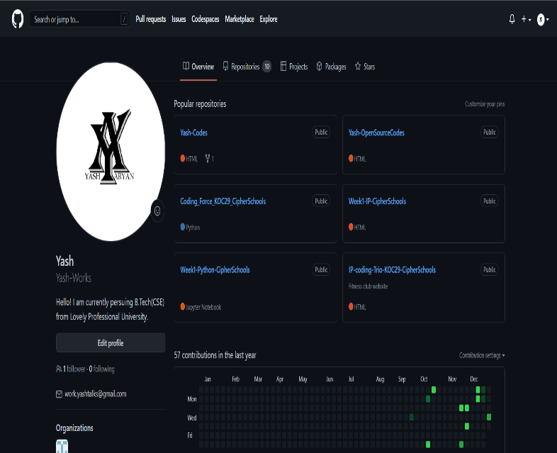  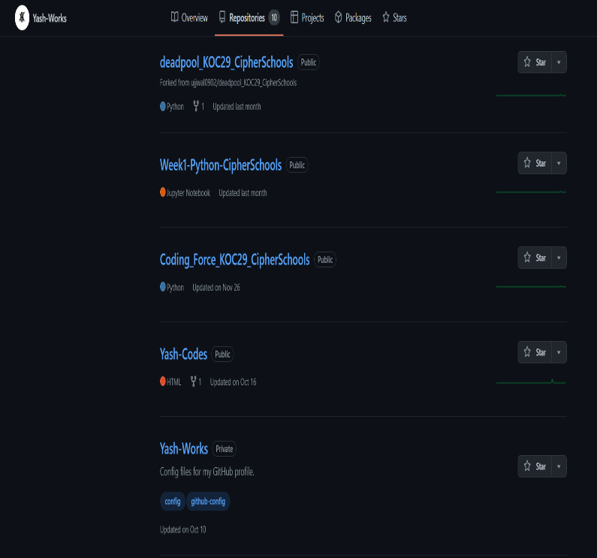 | Created 11 Repositories
Figma | https://www.figma.com/@yashsiwachworks | 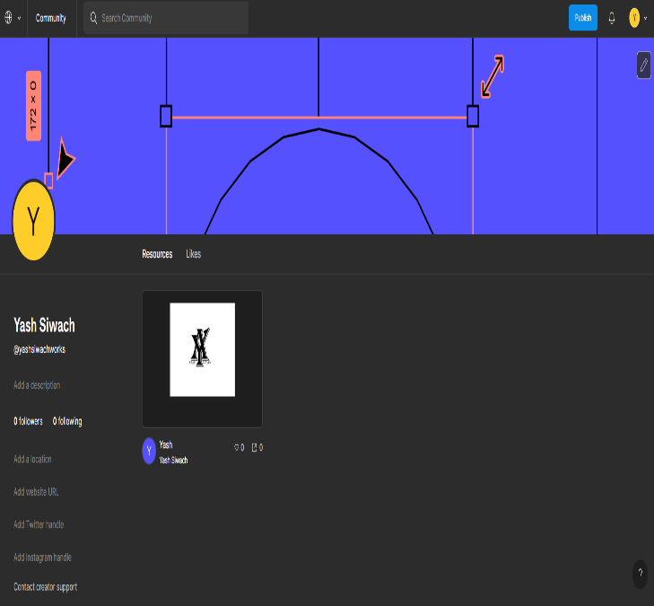 | Designed Logo
Quora | https://www.quora.com/profile/Yash-Siwach-12 | 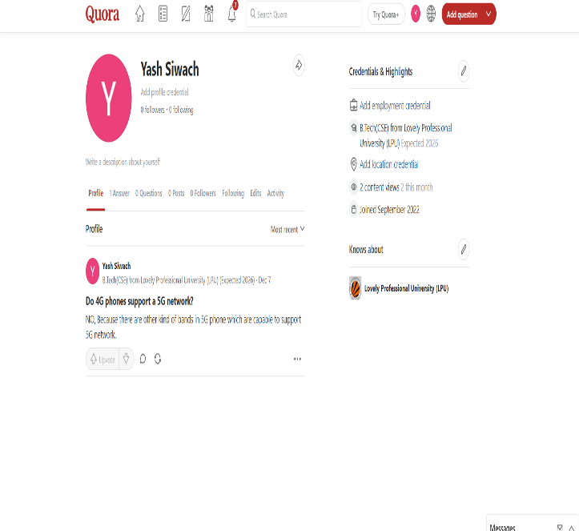 | Answered Questions
Stack overflow | https://stackoverflow.com/users/20715834/yash-siwach | 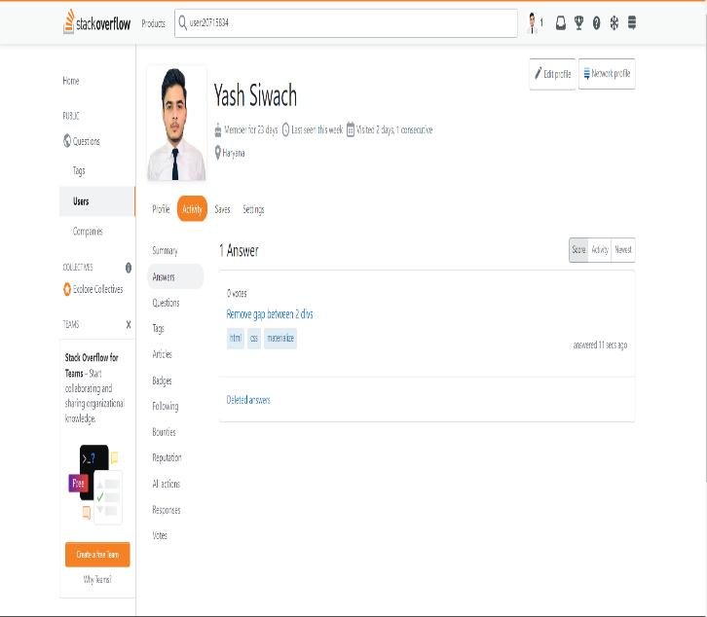 | Answered Questions
Linkedin | https://www.linkedin.com/in/yashsiwach-work/ | 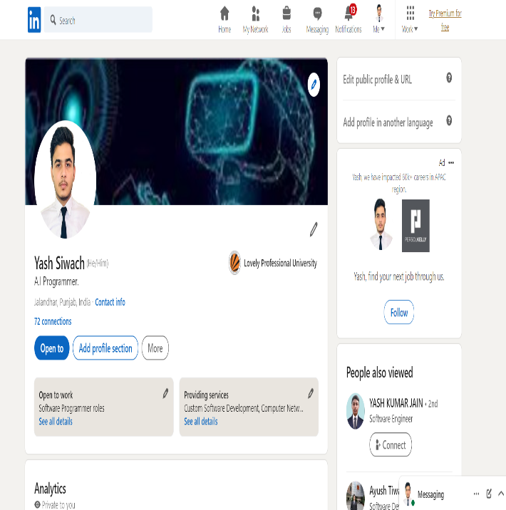 | Connected To Many Faculties of Lovely Professional University
HackerRank, | https://www.hackerrank.com/work_yashtalks | 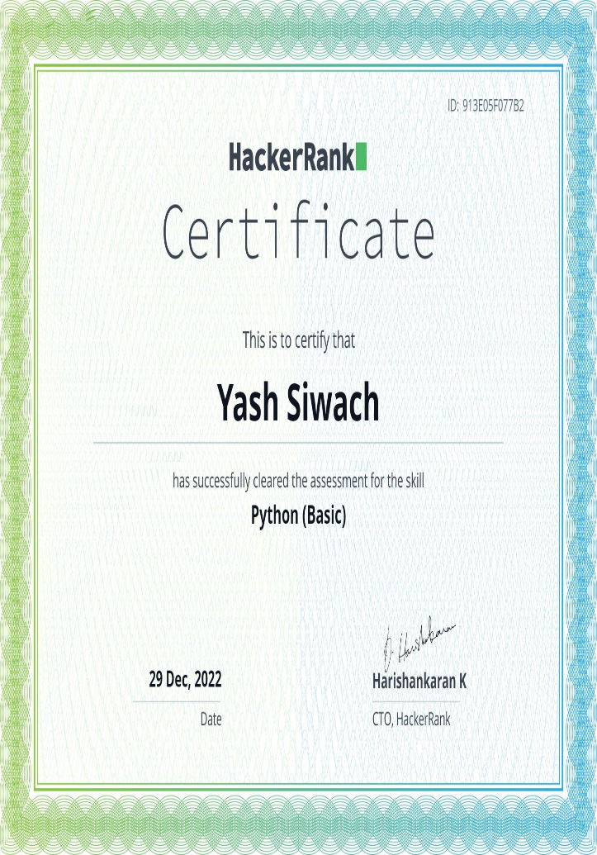 | Python Certification
HackerEarth, | https://www.hackerearth.com/@work.yashtalks | 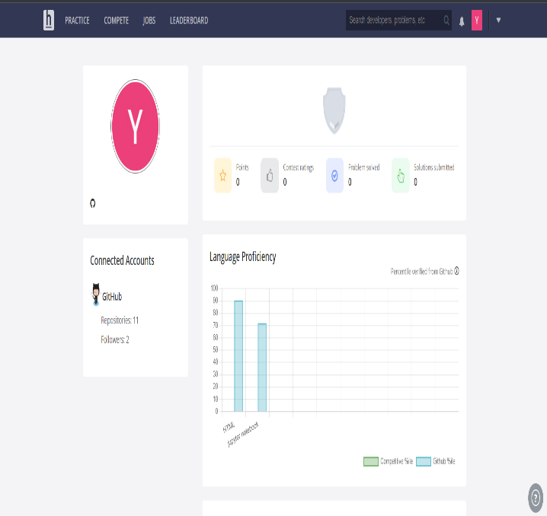 | Python Problems Solving
GeeksforGeeks | https://auth.geeksforgeeks.org/user/yashworks | 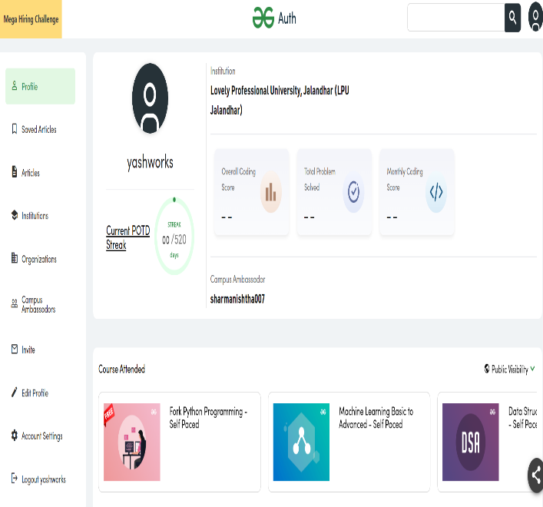 | Python Course Involvement
CV (with projects undertaken and any MOOC’s completed) | https://drive.google.com/open?id=1DKAfOC7F-AoFczI15wpXoC_UOFqm4f8B&authuser=0&usp=drive_link | 